Lab Asessment-6

Q)

package p1;

public class Primes{

public static boolean checkForPrime(int a){

if(a<4) return a>1;

for(int i=2;i<a/2;i++)

if (a%i==0) return false;

return true;

}}

import p1.\*;

import java.util.\*;

class TwinPrimes{

public static void main(String[] args){

Scanner in=new Scanner(System.in);

System.out.println("input limit to check for twin primes till:");

int n=in.nextInt();

if (n<5) return;

for(int i=3;i+1<n;i+=4){

if(Primes.checkForPrime(i)&&Primes.checkForPrime(i+2)) System.out.println(i+", "+(i+2));

if(i+2<n&&Primes.checkForPrime(i+1)&&Primes.checkForPrime(i+3)) System.out.println((i+1)+", "+(i+3));

}

}

}

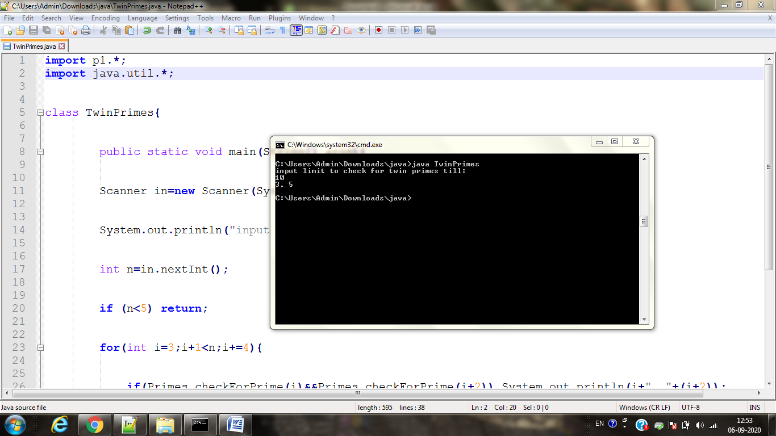

Q)

package p2;

interface AddSub{

void add();

void sub();

}

class Test1 implements AddSub{

void add()

{

int a=1,b=2;

int c=a+b;

System.out.println("Addition=" + c);

}

void sub()

{

int a=4,b=2;

int c=a-b;

System.out.println("Subtraction=" + c);

}

}

package p3;

interface MulDiv{

void mul();

void div();

}

class Test2 implements MulDiv{

void mul()

{

int a=1,b=0;

int c=a\*b;

System.out.println("Multiplication=" + c);

}

void div()

{

int a=4,b=1;

int c=a/b;

System.out.println("Division=" + c);

}

}

import p2.\*;

import p3.\*;

public class Run{

public static void main(String[] args)

{

AddSub as=new Test1();

as.add();

as.sub();

MulDiv md=new Test2();

md.mul();

md.div();

}

}